Assignment MTH 100
Incharge Minahil Arshad

Question No 01 :

To find the composite function where:

- f(x) = 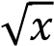
- g(x) 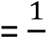
𝑥
- h(x) = 𝑥²

we will calculate it step by step.

Step 1: Find h(x)

First, we start with h(x):
H(x) = x²

Step 2: Find g (h(x))

Now, substitute h(x) into g(x): G (h(x)) = g(x²) = ¹₂
𝑥

Step 3: Find f (g (h(x)))

Now, substitute g (h(x) into f(x) :
f(g(h(x))) = f ( ₂ ₂
1
𝑥
)

=

√
1

=

1
|
𝑥

|
𝑥

Final Result

Thus, the composite function (f o g o h) is:
1 (f o g o h ) (x) =
|𝑥|
Question no 2 :

Determine the domain and range of fog if f(x) = 1/x and g(x) = x + 1.

Answer
To determine the domain and range of the composite function ￼, where

- f(x) = ¹
𝑥
- g(x) = x+ 1

we will first compute (f o g ) (x) and then analyze its domain and range.

Step 1: Find (f o g ) (x)

The composite function is defined as:
(f o g) (x) = f (g(x)) = f(x+1)

Substituting g(x) into f(x)
F(x+1) = ¹
𝑥+1

Step 2: Determine the Domain

The domain of (f o g ) (x) = ¹ consists of all x values for which the function is defined. The function is
𝑥+1
undefined where the denominator is zero:
X+1 ≠ 0 → x ≠ -1
Thus, the domain is:
Domain: (-∞,-1) U (-1 , ∞)

Step 3: Determine the Range

The range of f(x) = ¹ is all real numbers except zero. Since g(x) shifts the input but does not affect the
𝑥
overall behavior of f beyond avoiding division by zero, the range of (f o g) (x) = ¹ remains the same.
𝑥+1

As x approaches -1 from the left, ¹ approaches -∞, and as x approaches -1 from the right,
𝑥+1
1
￼ approaches + ∞ Therefore, the function will never equal zero.
𝑥+1

Thus, the range is:
Range : (-∞ ,0 ) U (0 , ∞)

Question: 3
Solve the system of linear equations:
3х + 4y - 72 = 2 -2x+y-2=-6 x+ y+z = 2

Simplify each equations:
Equation 1 3х + 4y - 72 = 2
Equation 2 -2x+y-2=-6
Equation 3 x+ y+z = 2

Step 2 Solve for Y in term of X equation 2
From eq 2
Y=2x-4

Step 3 : Substitute y = 2x-4 into equation 1
3x+ 4(2z-4) = 74
3x +8z -16 =74
11x = 90
X =
90
11

𝟗𝟎
Step 4 : Substitute x = into y = 2x-4 to find y
𝟏𝟏
Y = 2 (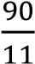) – 4
Y = 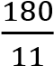 − 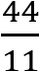
136
- =
11

𝟗𝟎 𝟏𝟑𝟔
Step 5 Substitute x = and y = into eq 3 to find Z
𝟏𝟏 𝟏𝟏
X+ y+ z = 2
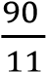 + 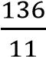 + z = 2
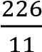 + z = 2

- = 2- 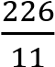
Z = 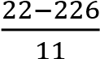
Z=
−
204
11

Question No 04 :
Solve the quadratic equation y = x² + 3x + 1.
Answer

Use Quadratic Formula
= 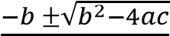
2𝑎𝑐
a = 1, b = 3 c = 1
Put all values in above formula:
X 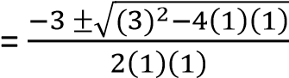
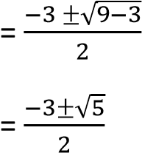

The solutions to the Equations are:
X 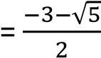 , x = 

